## Meeting Minutes:

December 17th, 2014

|  |  |  |  |
| --- | --- | --- | --- |
| NO | MINUTES | ACTION ITEM ON | STATUS |
| 1 | Figure out XLSX file Limit and Linked in Message Limit. Since application is going to send custom email message it is important to have flexibility here | Muthu | Refer PROJECT FACT SECTION |
| 2 | Provide more description to the header given in XLSX configuration file. We should be able to make use of Comments/Note  **Example:** EMAIL,PASSWORD,OFFSET,COUNT, TIMEOUT - It should be elaborated so that anyone can understand while running program | Muthu | Not Started |
| 3 | Separate out Input data from configuration file. This will help Vishal to use third party/team to send input file without have to share entire configuration file | Muthu | DONE. Both files are kept separate in XLSX format |
| 4 | Update program with informational message while running.  **Example:** While starting application it pops-up dialog window which should be given with notes for user to understand what they should with dialog window | Muthu | DONE. TAKEN CARE |
| 5 | During demo it was figured out that following URL kind is not working as it gives drop-down option for user to select the Connect button.  <https://www.linkedin.com/pub/trisha-fox/aa/92/1a1> | Muthu | DONE. Program takes care of such porfile links now |
| 6 | We will need more test accounts while we progress | Vishal | COMPLETED |

## Meeting Minutes:

January 2nd, 2015

|  |  |  |  |
| --- | --- | --- | --- |
| NO | MINUTES | ACTION ITEM ON | STATUS |
| 1 | Provide JAR and input file and other configuration file to Vishal | Muthu | COMPLETED |
| 2 | Change INPUT column name as INPUT_FILE_NAME_WITH_LOCATION | Muthu | COMPLETED |
| 3 | Provide Trustable Proxy provider | Muthu | COMPLETED. Refer Finds and Facts section |
| 4 | Vishal to provide 5 more test accounts and provide profile_link for those sample accounts given earlier after security verification | Vishal | COMPLETED |
| 5 | Vishal to test the program at his machine to get better understanding and for further fine tuning of application | Vishal | WIP |
| 6 | There are two major items to be implemented | Muthu | COMPLETED |

## Task Status

Last Updated: January 1st, 2015

|  |  |  |
| --- | --- | --- |
| NO | TASK | STATUS |
| 1 | Fix the bug, code clean up/move elements to config file, CSV file validation upfront. | COMPLETED |
| 2 | Handle more than type of “Send Invitation” Page (One with options, One with email directly) | COMPLETED |
| 3 | Upgrade Selenium to latest and test | COMPLETED |
| 4 | Demo to client | COMPLETED |
| 5 | Analyze and fix (or workaround or provide option to client) default vs custom message delivery by LinkedIn | COMPLETED |
| 6 | CSV file to take additional options to send invite based on Colleague/Classmate/We have done business together option. | COMPLETED |
| 7 | Demo to client | COMPLTED |
| 8 | Proxy based access (Round robin) | COMPLTED |
| 9 | Demo to client | WIP |
| 10 | Take input from file using File Dialog window | COMPLETED |
| 11 | Documentation and project closure | WIP |
| 12 | Handover | Not Started |

## Finds & Facts

January 2nd, 2015

* At Linked-in Message size can’t be more than 300 Character. There is no restriction in XLSX file as it supports anything huge (Even Wiki)
* Linked-in will not send invite more than once. The only option is going to the message and doing resend. I tried “Withdraw” and send invite but it didn’t go. The number of days to wait in order to allow user again to send invite could be a configuration at linked-in backend.
* Refer <http://theundercoverrecruiter.com/linkedin-invitations/> to know more about invitations.
* Proxies can be purchased from <https://instantproxies.com/> (Suggestion only)
* Vishal to consider having note about not to decline invitation while sending invites using email option
* Linked-In is showing following page when there is nothing common between users. This should be the case when you try to send invite with someone who is new at Linked-In and there is no connection (direct/indirect) in his profile. Please note that I believe (assume) indirect connection can be at 3rd, 4th & N’th level (Require more time to experiment further to find this level better)

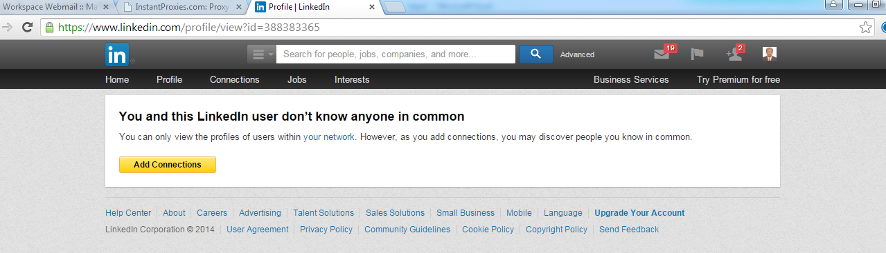

* Even after having some common connection, linked-in is showing page like the one below when we visit to the profile link page

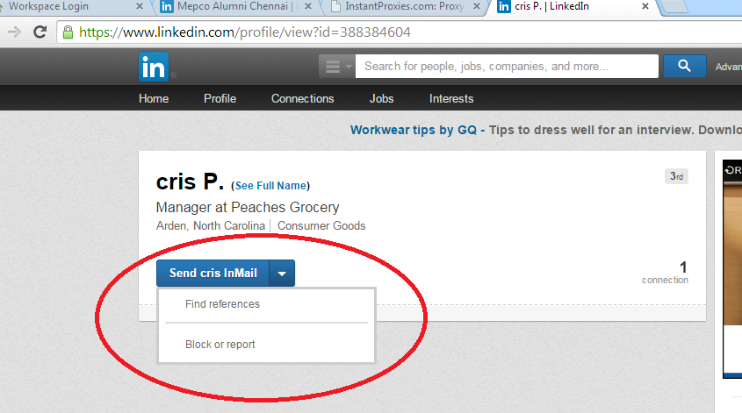

* With 3rd Degree connections as well we get only following page and don’t seem to have connect button. Looks like premium user will not have such restrictions.

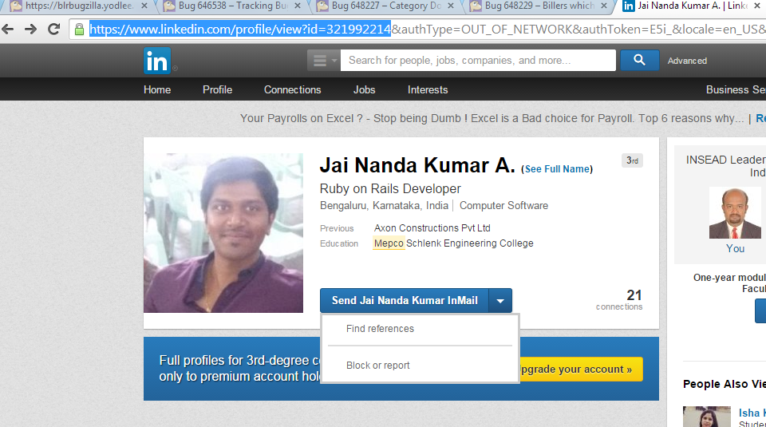

## Meeting Minutes:

December 11th, 2015

|  |  |  |  |
| --- | --- | --- | --- |
| NO | MINUTES | ACTION ITEM ON | STATUS |
| 1 | Print configuration input so that we will know how many records are processed and remaining to be processed | Muthu | COMPLETED. Printing this info and more information can be available with –versbose option |
| 2 | Document on how to use InstantProxies | Muthu | COMPLETED |
| 3 | Test Profile link with old session key in it | Muthu | COMPLETED. THE FULL URL WORKS FINE |
| 4 | There is a Pause after clicking connect button. Analyze to find the reason | Muthu | COMPLTED. There is a time linked takes to load option values dynamically in the backend |
| 5 | Test the program and provide results | Vishal | WIP |
| 6 | Print serial number along with full name | Muthu | COMPLETED |

## How to configure Instant Proxies

